Wood chipper Manual

IMPORTANT: Read through this owner’s manual carefully before operating this equipment
to insure the safety of yourself and others.

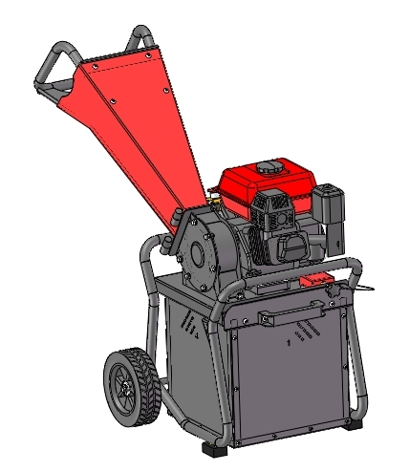

Due to continuing improvements, actual product may slightly differ from the product described.

Introduction
The gasoline power wood chipper is mainly used in the garden, modern agriculture for small trees, waste branches, leaves and woody material crushing, after that they become debris particles which is easy to store and transport, can also be used for composting directly. Due to the using of efficient gasoline engine, this wood chipper is not be restricted by the site environment and other conditions and can much conviniently using for operator.

This manual must be carefully read and fully understood by the operator before using this wood chipper to avoid unnecessary damage and hurts. In this manual, we focus on the safety matters, structural characteristics, main technical parameters, working process, use instructions, maintenance, installation, handling storage, troubleshooting and other aspects of the wood chipper, and also equipped with a sketch to show operator the necessary usage and maintenance knowledge for reference.

Part I: Safety Attentions
- This wood chipper cannot be used for any other purposes that not stated in the user manual.
- Only original machines and parts are allowed. Safety risk will be increased by using non-approved parts,which is not allowed. We are not responsible for any accidents or damages caused by the use of non-original parts.
- You must use it under the proper guidance of a dealer or someone who has experience in using it in the first time.
- Minors are not allowed to touch and use this machine.
- This machine can only be lent to people who are familiar with the machine and have a reasonable knowledge of its usage,together with safety and operating instructions.
- Check carefully if all the safety protection parts of the machine are installed in place and confirm all the fasteners are firm and reliable before using the machine.
- Choose a suitable flat working area before using this machine. This machine can only be used outdoors, need to keep away from no-noise workshop, laboratory, office and other places. The fuel of this machine is gasoline, which is flammable and explosive, operation and maintenance must be away from the fire, prevent static electricity and flammable and explosive materials to avoid burns, slide, fire, explosion, and other safety accidents.
- When using this machine, you must wear durable gloves, goggles, ear muffs, dust mask and non-slip shoes,and wear tight clothing to avoid personal injury caused by clothing involvement in the machine,
- Stop operation before any adjustment, refueling, cleaning.（Note: Do not smoke while refueling.）
- Check whether the wood chipper has good support to ensure stability when it works. (Note: Do not work on slopes, must be placed on a flat solid ground.)
- Proper maintenance must be carried out before and after use, which can avoid the occurrence of some safety accidents and extend the service life of the machine.。
- Read and understand this manual and related safety matters carefully before operating, otherwise it may cause injury or damage!

The following symbols are relevant when using this machine. They may also be displayed on the machine or be referred to in this instruction manual.
 | Read all safety warnings and all instructions, and save them for future reference. If this product is given to someone else, this instructions manual should also be handed over.
 | Safety caution. Denotes risk of personal injury or damage to the machine.
 | Do not dip your hand into moving parts
 | Beware of cutting off fingers.
 | Keep a safe distance from operating machines.
 | Beware of hurling objects.
 | Harmful noise.
 | Fire hazard.
 | Wear protective glasses.
 | Wear a dust mask.
 | Wear earmuffs.
 | Wear Gloves.

Part II:Technical parameters
Model：GBK-70-2QY
Chipping Capacity：50mm
Collection Box：40L
Displacement：212cc
Output power：4.3KW/3600rpm
Gasoline tank capacity：3.6L
Oil capacity：0.6L
Starting System：Recoil
Fuel Type：Unleaded Gasoline
Carton Measurement:560*500*640mm

The above maximum wood chipper capacity data was obtained from the actual chipping test of bamboo with 90% moisture content and paulownia with 80% moisture content. Due to the variety of wood materials that can be chipped by this machine, and the differences in hardness, toughness, moisture content and so on, the actual maximum particle diameter and efficacy of this machine may be different from the above related parameters. The manufacturer recommends that the best particle diameter is 40MM, the specific chipping method and the selection of raw materials see the instructions and precautions.
All of the above maximum speed of the blade drum is measured at the engine output speed at 3600rpm.

Part III: Structural Feature
This machine has safe protection, solid structure and smooth operation. It consists of (1)engine, (2)feed hopper, (3)rack base, (4)wheels, (5)collection box, (6) chipping room, (7) blade drum, (8)rubber mats, (9)emergency stop, (10) interlock switch cover, (11)interlock switch, (12)knob (as picture attached).
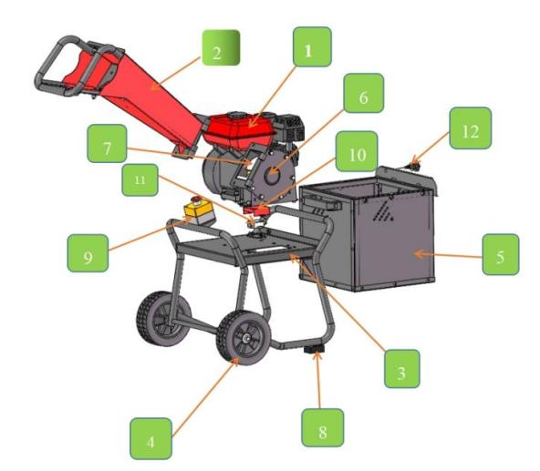

Part IV: Assembly the Wood Chipper
Step 1. Upside down the rack base, fixed the rubber mats and wheels.
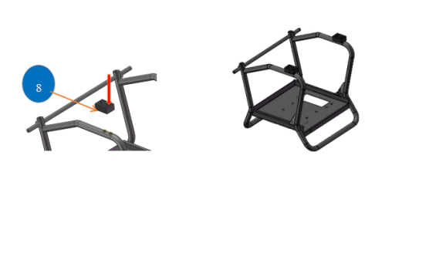 | 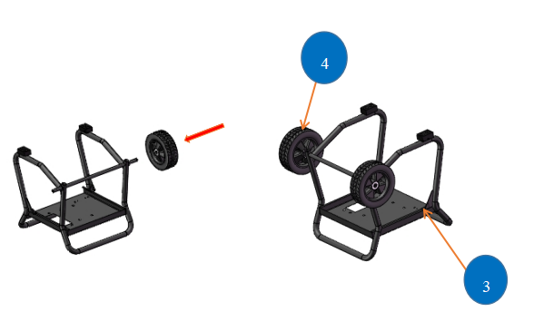

Step 2. Fix the main chipping room with engine on the rack base. Add the feed hopper, then fix the feed hopper handle with bolts, as following.
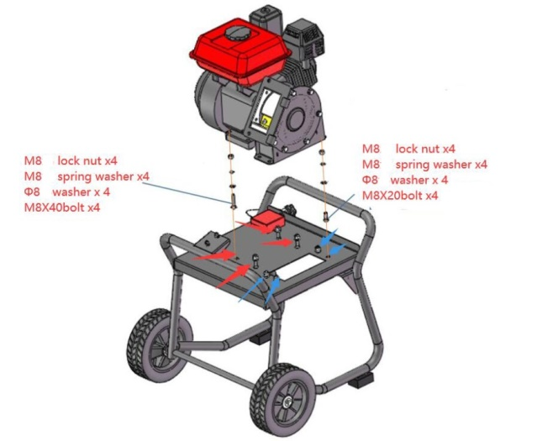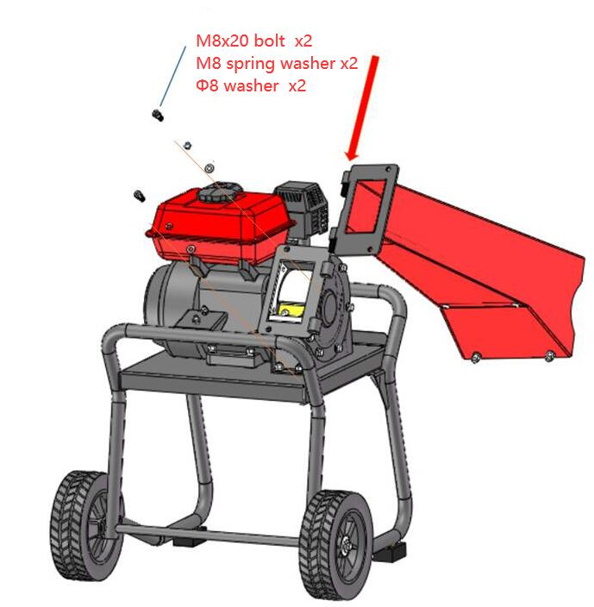
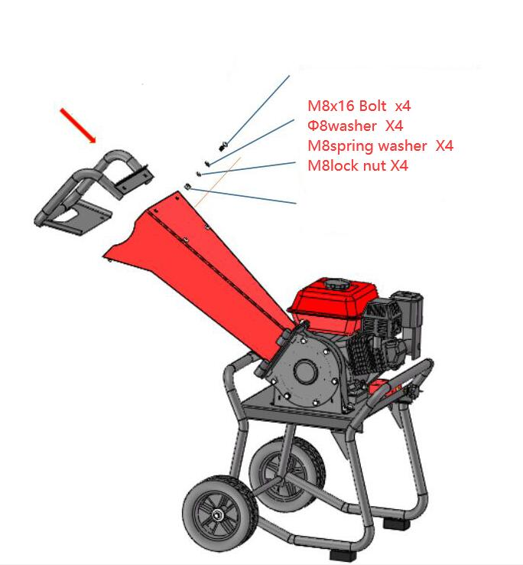

Warning – while completing the assembly of your machine, do not place your hands or any other body parts within the radius of the rotary cutting wheel. Do not touch the blades with your hands or any other body parts

Step 3. Collection box combined as following and fixed the handles on the box.

No. | name | qty | remarks
1 | Frame bar | 1
2 | Box side 1 | 1
3 | Box side2 | 1
4 | Box side3 | 1
5 | Box side4 | 1
6 | Bottom | 1
7 | Panel | 1
8 | handle | 2
9 | Hexagonal socket head bolt | 4 | M8*20
10 | M8nut | 2
11 | Hexagonal socket head bolt | 6 | M8*16
12 | Hexagonal socket head bolt | 8 | M6*30
13 | M6nut | 30
14 | Hexagonal socket head bolt | 22 | M6*8
15 | Hexagonal socket head bolt | 2 | M8*2

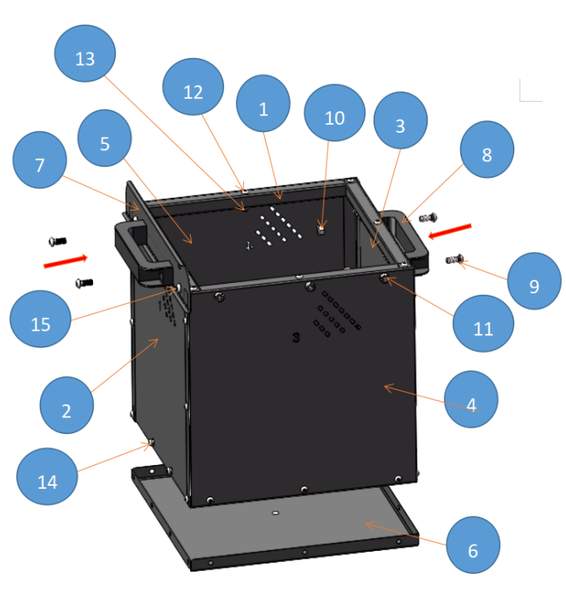

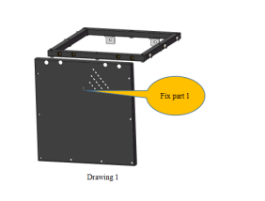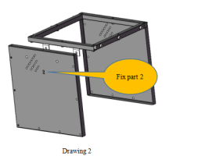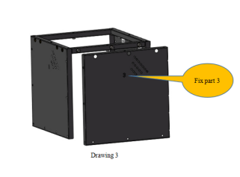
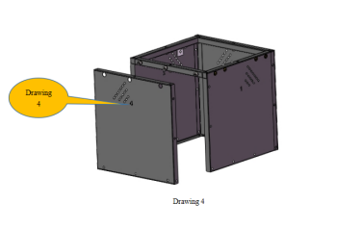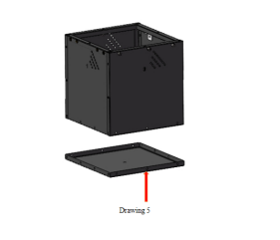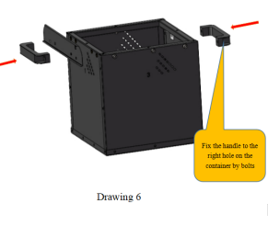
Step 4. Fixed the emergency stop on the rack, and push the collection box to it’s rail. Screwed the interlock switch.
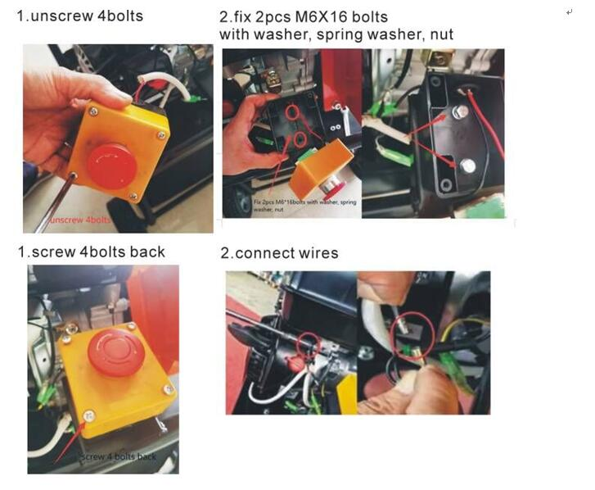
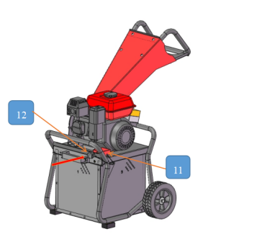 | 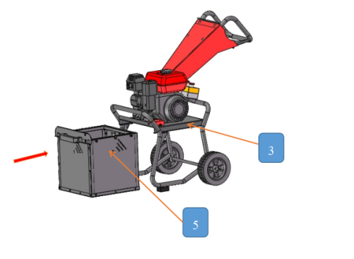
Part V: Operating the wood chipper
Safety with Gasoline ‐ Powered Machines
WARNING
Gasoline is a highly flammable liquid. Gasoline also gives off flammable vapor that can be easily ignited and cause a fire or explosion. Never overlook the hazards of gasoline. Always follow these precautions:
A．Never run the engine in an enclosed area or without proper ventilation as the exhaust from the engine contains carbon monoxide, which is an odorless, tasteless, and a deadly poisonous gas.
B．Store all fuel and oil in containers specifically designed and approved for this purpose and keep away from heat and open flame, and out of the reach of children.
C．Replace rubber fuel lines and grommets when worn or damaged.
D．Fill the gasoline tank outdoors, after the engine off and cool completely. Don't handle gasoline if you or anyone nearby is smoking, or if you're near anything that could cause it to ignite or explode. Reinstall the fuel tank cap and fuel container cap securely.
E．If you spill gasoline, do not attempt to start the engine. Move the machine away from the area of the spillage and avoid creating any source of ignition until the gas vapors have dissipated. Wipe up any spilled fuel to prevent a fire hazard and properly dispose of the waste.
F．Allow the engine to cool completely before storing in any enclosure. Never store a machine that has gas in the tank, or a fuel container, near an open flame or spark such as a water heater, space heater, clothes dryer or furnace.
G．Never adjust or repair with the engine running. Shut down the engine, disconnect the spark plug wire, keeping it away from the spark plug to prevent accidental starting, wait 5 minutes before adjusting or making repairs.
H．Never tamper with the engine’s governor setting. The governor controls the maximum safe operation speed and protects the engine. Over‐speeding the engine is dangerous and will cause damage to the engine and to the other moving parts of the machine. If required, see your authorized dealer for engine governor adjustments.
I．Keep combustible substances away from the engine when it is hot.
J．Never cover the machine while the muffler is still hot.
K．Do not operate the engine with the air cleaner or the carburetor air intake cover removed. Removal of such parts could create a fire hazard. Do not use flammable solutions to clean the air filter.
L．The muffler and engine become very hot and can cause a severe burn; do not touch.
M. If this machine has not been used for a long time, it is necessary to pour out old oil (loose this bolt ) before adding the new oil, otherwise the engine may not be started.
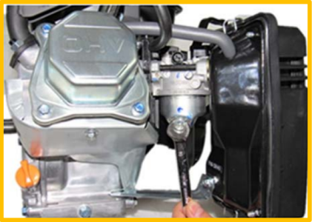
Important: This machine is supplied without fuel and oil. Fill, before use, fuel and oil to the correct level. Operating the machine without, with too little or the incorrect oil can cause serious motor damage that is not covered by the warranty.

WARNING
- Read and understand all instructions, safety precautions, and/or warnings listed in “PART I: Safety Attentions” before operating the wood chipper. If any doubt or question arises about the correct or safe method of performing anything found in this manual, please contact the dealers in your area.
- When operating the Wood Chipper, make sure you are standing in the safe operating area. You must always stay in the safe operating area when feeding branches into the machine. Never place any part of your body into a position that causes an unsafe operating condition.
- Before loading and operating the wood chipper, always wear protective gear, including safety goggles, hearing protection, tight-fitting gloves without draw strings or loose cuffs, and steel-toed shoes.
- Knowing the correct and incorrect methods of Chipping woods. Never using an incorrect or unsafe method.
- Block or short&thick wood are not allowed to be chipped separately, for the safety of the operator and the good of the blades, they are better to be crushed with branches .
F．Thick wood end go firstly then thin end.

Prepare:
1. Check engine condition
2. Fill engine with right type engine oil (according engine manual).
3. Check blade condition make sure the blade is not dull and the blade‐fan is not blocked.
4. Check the tank for enough oil (about 2/3 volume).
5. Check bolts condition and if all bolts are tight.
6. Check safety switch in function.

Starting
- Position your Wood Chipper on flat, dry ground, make sure the machine cannot be moved.
- Set the emergency stop to “ON” position and the interlock switch is connected.
2. Make sure the fuel shut‐off valve is in the “ON” position.
3. Move the choke control lever to the “CHOKE” position (should only be needed if the engine is cold).
4. Move the throttle control lever to the “FAST” position.
5. Gently pull the starter cord until you feel resistance, then pull the cord firmly until the motor starts.
6. Move the choke control lever (if used for cold engine) slowly back to the “RUN” position when the engine is running well.
7. If the wood chipper has not been running (cold engine), warm up the engine by running the engine at half throttle for 3 to 4 minutes, then advance the engine throttle control to the maximum speed.

Stopping
- Press the emergency stop to stop the engine.
- Turn the “ON/OFF” switch to “OFF” position on the engine.
- Loose the interlock switch on the collection box position can also stop the engine.
- Set the fuel level in the “OFF” position. The motor will stop running within minutes due to a lack of petrol.

When Blocked
If the drum stops while chipping woods or branches, the engine should be stopped, and take out the woods which stuck the drum, and then restart the engine, and chip again.

If the machine starts to make an unusual noise or vibrate, shutdown the engine, disconnect the spark plug wire .
wait 5 minutes for the engine to cool down, then inspect for damage. Vibration is generally a warning of trouble. Check damaged parts and clean, repair and/or replace as necessary. If the machine topples over during operation, immediately turn off.

Check all hardware for tightness before each operating
A Note to All Users
List of warnings and cautions cannot be all‐inclusive. If situations occur that are not covered by this manual, the operator must apply common sense and operate this wood chipper in a safe manner. Contact the dealers for assistance in your area.

PART VI: Maintaining the Wood Chipper
Regular maintenance is the way to ensure the best performance and long life of your machine.
Check all the parts regularly with 1-2 times monthly including blades,etc. Replace the blades as soon as the chipping performance begins to deteriorate. The blunt blades will lower working efficiency and cause the damage of machine.
Please refer to this manual and the engine manufacturer's user manual for maintenance procedures.
WARNING
Before performing any maintenance procedure or inspection, stop the engine, wait five minutes to allow all parts to cool. Disconnect the spark plug wire, keeping it away from the spark plug.
Do not smoke during the following activities. Do not perform work in the vicinity of sparks, flames or open flames.
Never clean the machine with water or a high-pressure cleaner. Water in the machine can cause a short circuit or corrosion. Remove large waste with the help of a soft brush.
Engine Service
Refer to the engine manufacturer’s user manual for engine maintenance.

Maintenance Schedule
Proper maintenance extends this life of the machine and ensure safe and trouble-free use.
Never carry out maintenance work while the motor is running.
 | Action | Every use | First month or 20 hours | Every 3 months or 50 hours | Every 6 months or 100 hours | Every 12 months or 300 hours
Motor Oil | Check Level | x
Motor Oil | Replace |  | x |  | x
Spark Plug | Check electrode distance, clean |  |  | x
Spark Plug | Replace |  |  |  |  | x
Air Filter | Check | x
Air Filter | Clean |  |  | X* | X*
Air Filter | Replace |  |  |  |  | X*
Fuel Lever | Check and adjust when motor has cooled down |  |  |  |  | x
Fuel tank and filter | Clean and replace if necessary |  |  |  |  | x
Fuel line | Check and replace if necessary | x
Carburetor | Check | x
* More often when used in dusty environments.

PART VII:Transport and Storage
Switch off the motor and close the fuel lever before moving the machine.
If the machine is taken out of use for a longer period of time, you must empty the fuel tank and change the oil. This prevents problems with the restart.
- Allow the motor to cool before storing.
- Empty the fuel tank.
- Store fuel in containers specially designed and approved for this purpose.
- Store fuel in a cool, well-ventilated place, away from sparks, open flames, or other sources of ignition.
- Never store fuel or a machine with fuel in the tank in a building where fumes can come into contact with sparks such as an open fire or a boiler, oven tumble dryer.
- Change the oil.
- Cover the machine and place it in a clean and dry environment.

Part VIII:Troubleshooting
The common faults |  | Elimination method
1 | The engine cannot be started | Read the engine users’ manual, check the fuel ON-OFF, see if it’s ON, check if gets enough fuel and motor oil, check the emergency stop button is on, check the interlock switch is connected.
2 | Engine flameout midway | Check if the engine is stopped by overloading, check if something blocked in the chipping hopper, check the emergency stop button and interlock switch, and also check whether the fuel is out.
3 | The hopper blocked | Stop the machine and remove the feed hopper. Don’t touch the blade during the working, make sure your hands not to be cut by the blades.
4 | Has strange noise | Stop the machine, check if the fastener gets loose, if not, let the professionals to check the repair.
5 | The blade destroyed | Go to the professional repair point to change or repair the blades.
6 | The material grinding not sufficient | Let the professional to adjust the blade space, the recommended space for chipping is 1.5mm-3mm.

